**CS 570 Software Testing**

# HOP01B – Java SDK in VSCode

1/31/2019 Developed by Sam Chung

School of Technology & Computing (STC)

City University of Seattle (CityU)

**Caution**

* If you already finished this module through any CityU Technology Institute (TI) courses,  
  just skim this module and skip it.
* Some version numbers may not match with the newly released ones.  
  If so, stay with the most recent ones.
* We target Windows OS. So, Mac may have different options.
* We cannot explain every steps. This cookbook always needs your own creative judgement.

**Learning Outcomes**

* Learn how to install the Java SE Development Kit (JDK) on your local development environment.

**Install Java SDK**

1. Visit Java SE 11.0.2 (LTS) downloads at <https://www.oracle.com/technetwork/java/javase/downloads/index.html>

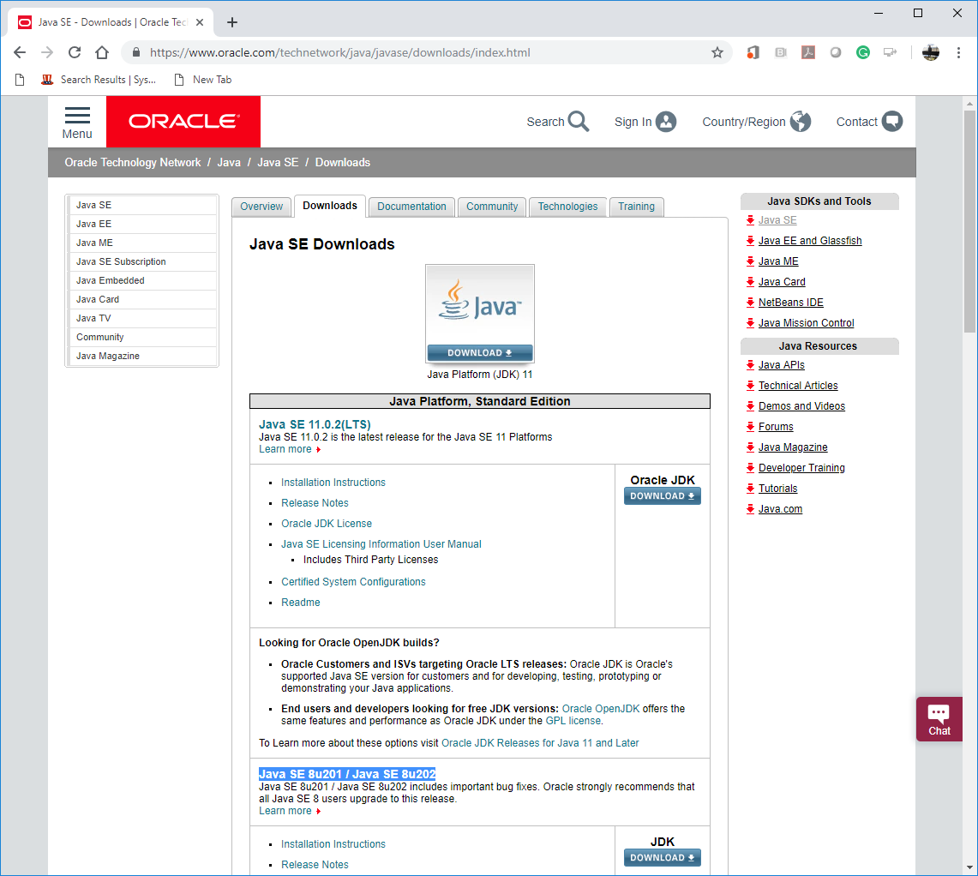

1. Press Oracle JDK Download based on your laptop.

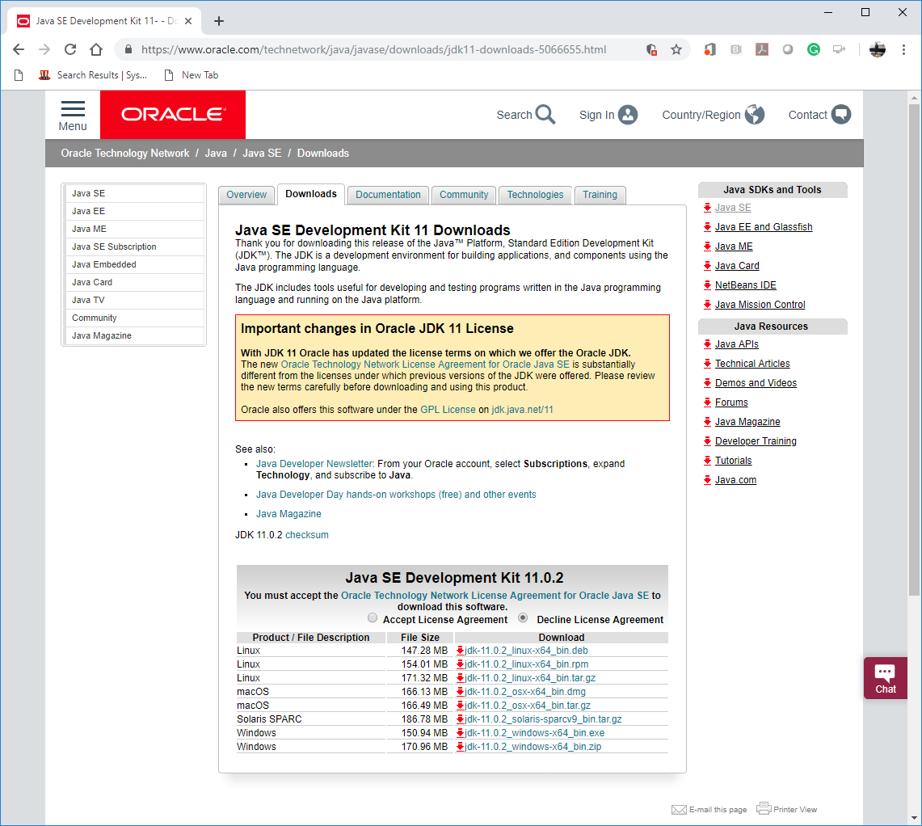

1. Accept the license agreement and download a correct Java SDK 11.0.2.  
   For my Windows Laptop, I chose “jdk-11.0.2_windows-x64_bin.exe”
2. Install the Java SDK.

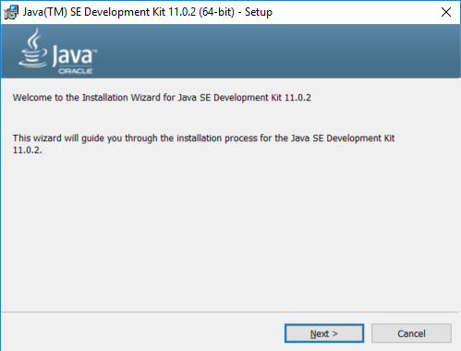

1. Visit the installed directory.  
   Remember the directory path.  
   For example, “C:\Program Files\Java\jdk-11.0.2”

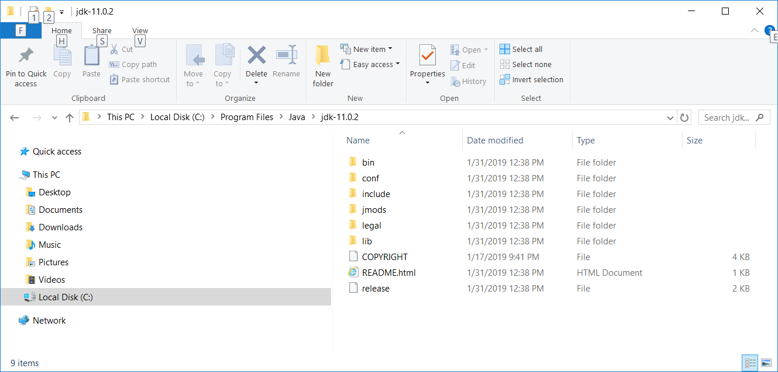

1. Set up the “JAVA_HOME” environment variable.  
   <https://docs.oracle.com/cd/E19182-01/820-7851/inst_cli_jdk_javahome_t/>   
   Assume that you use a Windows platform.
   1. Right click “Windows” icon  from your start menu bar.
   2. Select “System” menu item.
   3. On the Advanced tab, select Environment Variables.

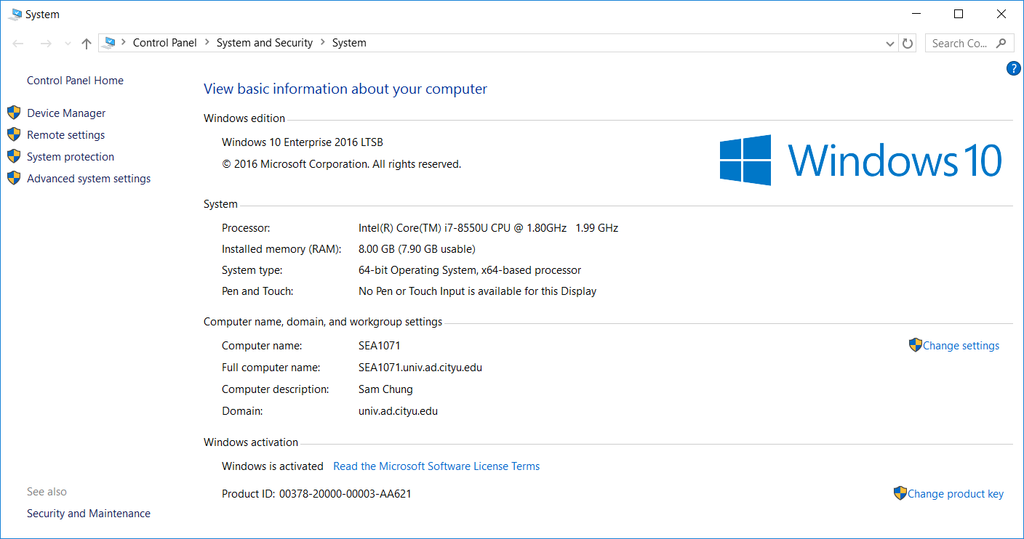

* 1. Select the “Advanced system settings” tab.

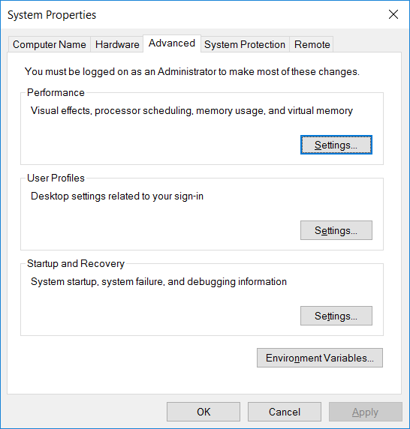

* 1. Select the “Environment Variable ….” Button.

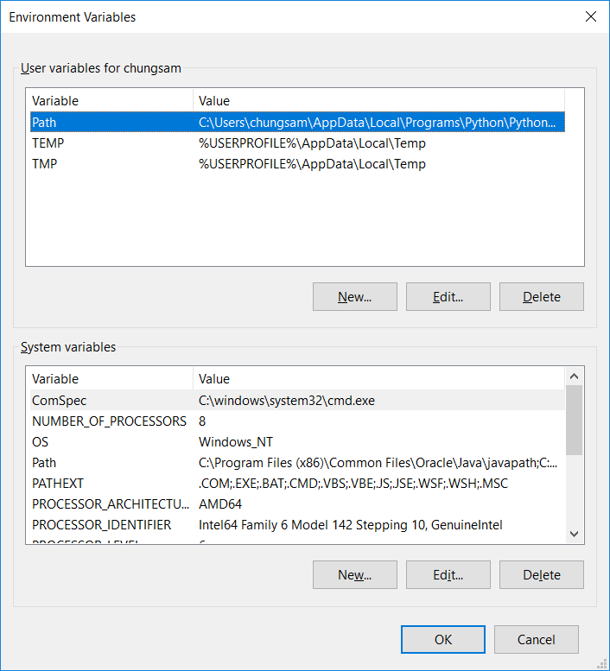

* 1. Add **a new system variable** “JAVA_HOME” to your system.  
     For example, select the “New…” of the “System variables”

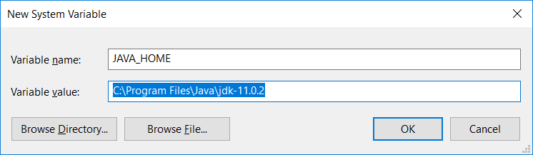

* 1. Edit the “Path” by using the “JAVA_HOME” environmental variable.

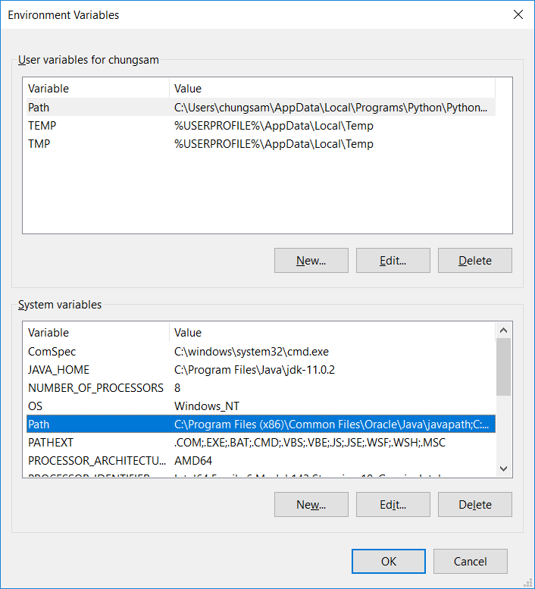

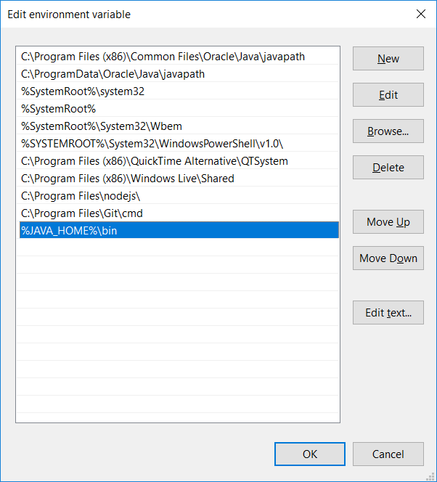

h) Add/Update the CLASSPATH to ensure Java finds and loads classes in Java programs as follows.

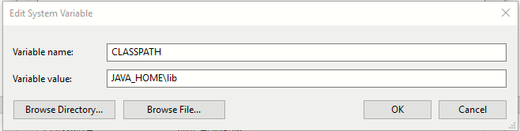

1. Test whether your Java SDK was correctly installed or not.
   1. Open your terminal (Windows: Windows + R, then “cmd”) (MacOS: Command + Spacebar, then “terminal”)
   2. Type “java -- version”

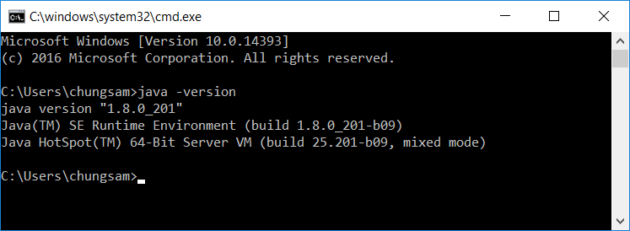

**Questions:**Answer each question.   
Show a good reference(s) to support your answer.

1. What does ‘Oracle LTS’ stand for?   
   For what purpose?

LTS in software means long term support. It means it will keep getting support by the developing company. Oracle LTS is the java developed by oracle.

1. Why do we use the “JAVA_HOME” environment variable?

JAVA_HOME tells applications where the JDK is installed. Various applications that use the JDK require that JAVA_HOME is set. In recent versions, Java itself does not require JAVA_HOME to be set.

1. Why do we define the “Path”?

These paths are used by the OS to find java, javac and other executables.

Java home environment variable allows the computer to locate executables such as java and javac that are located in the jdk folder. These executables are used during development, so a developer needs to use them. A user only uses jre (java runtime environment) so a user only needs to install jre and doesn’t need to set up environment variables.

1. What is the difference between “PATH” and “CLASSPATH”?

(Answer)

Setting path designates which directories the computer searches when looking for applications like java and javac.

The directory you set classpath to must have the .class files. When java program are executed with java command, current directory is searched for the .class file. If it’s not found, classpath directories are searched.

The default value of the class path is ".", meaning that only the current directory is searched.

This allows us to use classes without needing to go to their path. So we don’t really need classpath. We can just go to the path of the class and call it from there. If we don’t set classpath and don’t go to its path, we wont be able to find the class and get an error (main method not found error if I am not mistaken).